Method:

1. System Modelling:
   1. Modelling of PMSM:

General IM machines have electromagnetic dynamics on both the rotor and the stator. In that case, one needs five state variables, including that of the rotor and the stator to depict the overall system. However, the PMSMs have no rotor electromagnetic behavior. For this reason, it is sufficient to choose only three state variables about the stator $i_{sd}$, $i_{sq}$ and $ω_{s}$ to model the system.

Then the dynamic of PMSM in the d-q or rotor field coordinate can be expressed as:

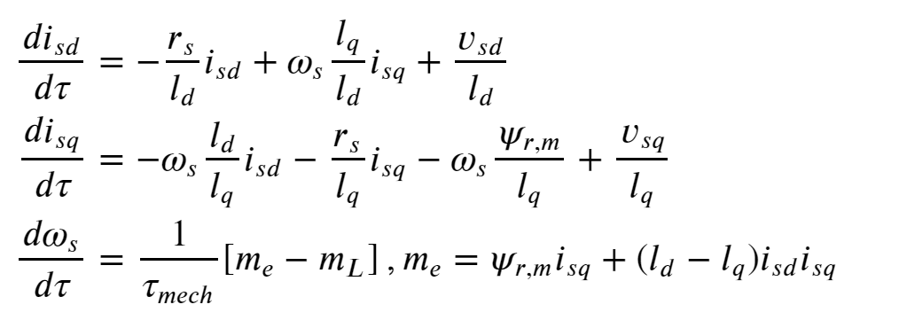

It can be seen that the model is non-linear, for the speed of the stator magnetic field is multiplying with the current state variables. One way to solve the non-linearity problem is to do linearization. But in AC machines, it is the supply frequency $f_{s}$ that decides the speed of the stator magnetic field $ω_{s}$. When a stator is supplied with voltage of $f_{s}$, the stator magnetic field rotates at $ω_{s}=2πf_{s}$. For this reason, $ω_{s}$ can be viewed as an input to the system.

* 1. System parameters

Two different PMSM with different parameters are used in the application for the front and back wheels of the vehicle. The parameters are listed in Tab 参考.

|  |  |  |
| --- | --- | --- |
| Parameter | PMSM #1 | PMSM #2 |
| $l_{d}$ d-direction inductance | 0.076 | 0.076 |
| $l_{q}$ q-direction inductance | 0.076 | 0.076 |
| $ψ_{r,m}$ permanent magnetic flux-linkage | 0.0204 | 0.025 |
| $τ_{mech}$ maximum mechanical torque | 500 | 500 |
| $r_{s}$ stator resistance | 0.031 | 0.02 |

1. Control Design:
   1. Goal of the Controlled System:

The controlled system should be able to follow the reference rotor speed. In this sense, the reference to the system is the rotor speed $ω$ instead of the current.

* 1. Control Method and Design:

The control system is formed by two parts: the speed-to-current mechanism and the current controller.

It is desired to adapt current control for the application. The reference input to a current control system is the reference current. Thus, to achieve current control with a reference being the rotor speed, a mechanism to translate the reference speed to reference current is required. Inspired by the VVVF control method, where a function to translate the reference speed to voltage is used, a simple map between the reference speed and current is developed as show in Fig.

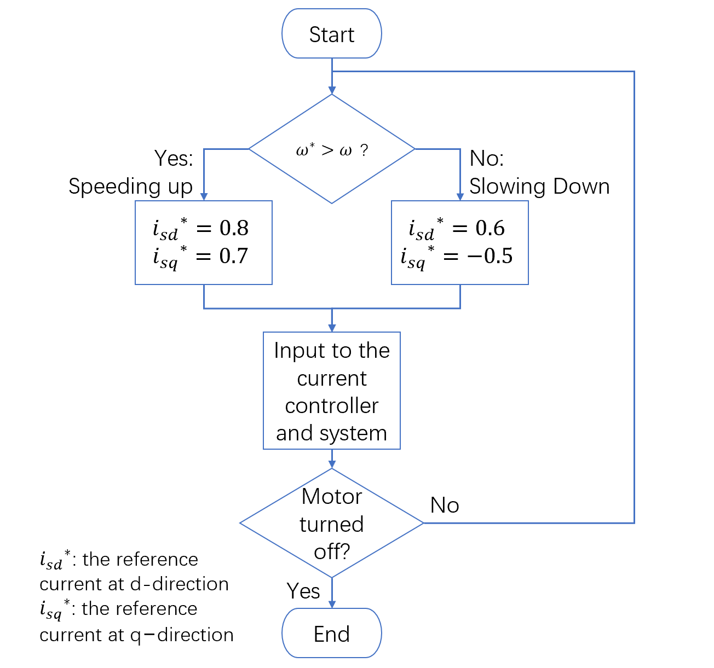

The overall system design with the speed-to-current mechanism and the current controller is shown in fig.

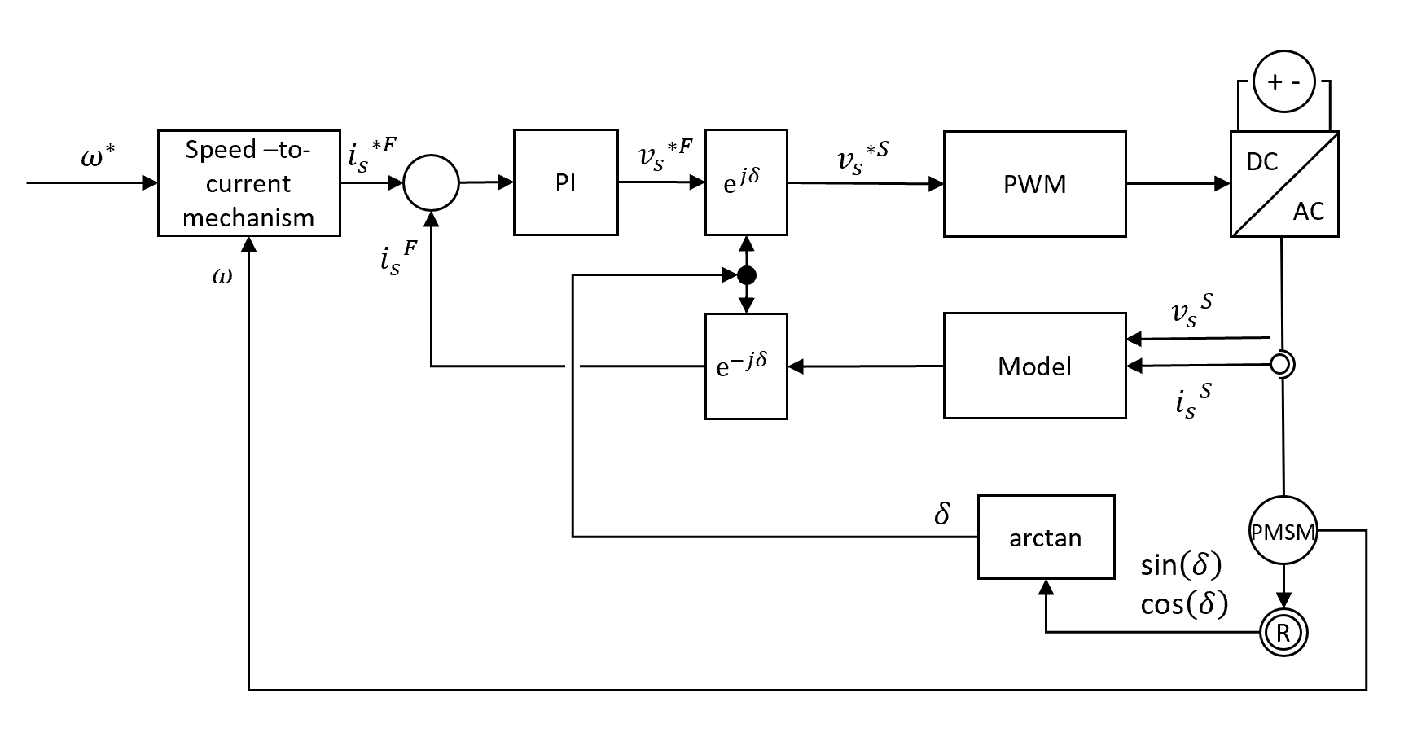

1. Simulation and Results:

In the results part, to verified the design of the control system by simulation, the report mimics a scene for the vehicle to speed up from 0% to 80% of the maximum speed, then run at the speed for a time and finally slow down to stop running. To achieve this, a sequence of reference rotor speed is set as commands. The first two-third of the command is set to be 80% of the maximum speed, for speeding up and uniform speed operations, while the rest are set to be 0 to tell the system to perform braking.

The simulation result for PMSM #1 of in no-load condition is shown in Fig, and that for PMSM#2 in no-load condition is shown in Fig.

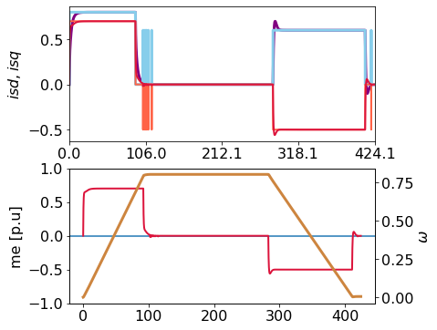

Load conditions